Martin County Opioid Settlement Community Partner Project
Request for Proposal
BACKGROUND
About the Opioid Settlement
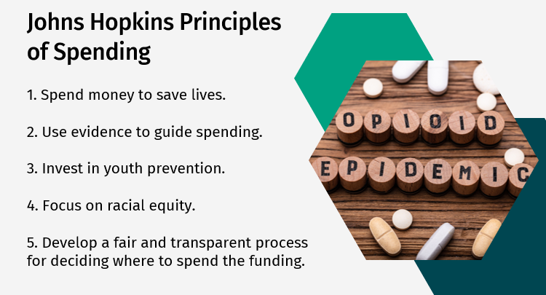
In 2021, Minnesota joined a $36 billion multistate settlement agreement with manufacturers and distributors of opioids. The settlement payments will be distributed over 18 years and payments are front-loaded. Minnesota is unique amongst other states in that the bulk of payments (75%) are going to local governments. The funds are restricted to an approved list of expenditures (evidence-based treatment and prevention activities).
Martin County’s Share of the Opioid Settlement Funds
At the end of June 2024, Martin County will have over $243,000 of payments distributed. In five years, Martin County will have had $525,000 in payments distributed. At the end of the settlement, on July 31, 2038, Martin County will have had $947,000 in payments distributed.
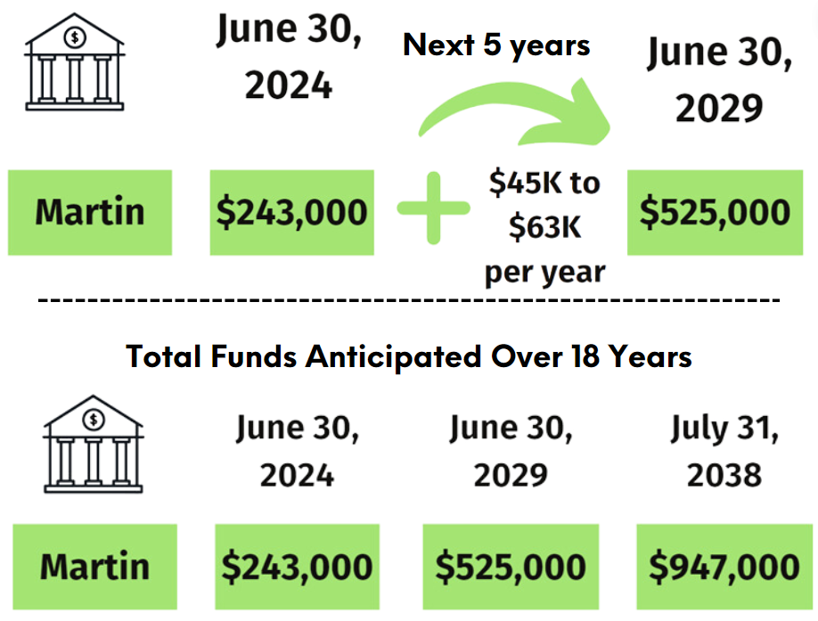

Opioid Settlement Funds Assessment
In Fall 2023, under the recommendation of Faribault and Martin Counties’ Stronger Together Coalition, the Martin County Board approved funding for an assessment of resources, needs and community funding priorities related to the opioid settlement spending.
The assessment included:
- A review of public data on opioid use and overdoses in Martin County, as well as services and supports available to residents,
- Two community meetings to learn about treatment and prevention resources related to opioids in Martin County,
- A survey of 140 community members, who shared about funding priorities, and
- A focus group of community members with substance use disorder that live in Martin County, and
- Key informant interviews with individuals who work locally with those with substance use disorder.
Assessment data was presented to the Stronger Together Coalition in May 2024. Martin County delegates voted on service priorities for Martin County’s Opioid Settlement Funds:

Treatment Priorities | Prevention Priorities
1. Hire peer support specialists or recovery coaches to connect people to services and supports  2. Within schools, develop and implement programs to screen for Opioid Use Disorder and refer individuals to treatment  3. Provide wrap around services, such as housing, employment training and counseling, to individuals in treatment and recovery for Opioid Use Disorder | 1. Fund programs in schools that have demonstrated effectiveness in preventing drug misuse.  2. Fund community anti-drug coalitions that engage in drug prevention efforts  3. Fund media campaigns to prevent misuse and public education campaigns related to emergency responses to overdoses and Good Samaritan laws

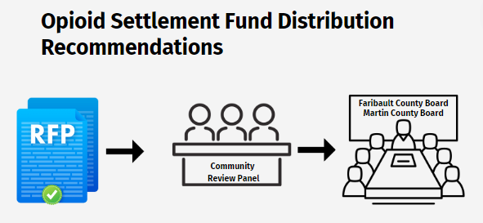
The Martin County Board of Commissioners accepted the Stronger Together Coalition’s recommendation to establish a request for proposal process to award Opioid Settlement funds utilizing the following guidelines:
- The review committee should NOT include any members directly submitting an RFP for funding to prevent conflict of interest.
- Projects that aim to impact strategies prioritized by the Opioid assessment receive priority towards funding.
- Funds are made available on reimbursement basis vs. providing a one-time frontloaded payment.
- Projects are capped at $24,000 (anything over would require additional reporting requirements).
- Funding is available annually and applicants can reapply for projects that demonstrate success in achieving outcomes.
- Of the pot of funding available for community projects, 50% would be designated to projects aimed at prevention strategies and 50% would be designated at projects aimed at treatment strategies, per the assessment results.
- Review committee recommendations are provided to the county board to make final funding decisions.
- The County Board of Commissioners can bring special consideration projects to the review committee at their discretion.
The Martin County Board of Commissioners designated Human Services of Faribault & Martin Counties as the lead agency to oversee the grant process. The duties include:
- developing the request for proposal application and materials,
- convening the review committee,
- oversight of the review process,
- summarize reviewers’ recommendations and provide information to County Board,
- maintain ongoing oversight of projects to ensure funds are spent as directed,
- supporting the County Treasurer with annual reporting, etc.

General Information
Announcement Title: Martin County Opioid Settlement Funds Request for Proposal
Letter of Intent: Friday, August 14th, 2026
Application Deadline: September 1st, 2026
RFP Materials can be accessed at Human Services of Faribault & Martin Counties Website: Opioid Settlement Funds (fmchs.com)
Submit Questions related to the RFP. Questions will be compiled and answered weekly between August 1 and August 31: Opioid Settlement Funds Application Questions Survey (surveymonkey.com)

Funding and Project Dates
Funding will be allocated through a competitive process. If selected, you may only incur eligible expenditures when the grant agreement is fully executed, and the grant has reached its effective date.
This is a competitive grant with a total estimated $124,074 for the funding period one January 2027 - December 2027.
By the middle of 2026, Martin Co will have received $254,783.11. As of August 2026, Martin Co has spent or encumbered $101,230 on remaining round two Opioid Settlement Community Grants. An additional $25,478.31 has been allocated for staffing and indirect costs to administer and oversee partner grants. The remaining $124,074.80 will be available to award in partner grants. Applicants may apply for up to $24,000. The estimated funding start date is based on contract agreement and awardee acceptance of funding.

Funding | Funding Period 1  January 1, 2027 – December 31, 2027
Estimated Amount to Fund | $124,074
Estimated Number of Awards | TBD
Estimated Award Maximum | $24,000
Estimated Award Minimum | No minimum

Future Funding
Funding to Martin County is provided in multiple settlement payments over 18 years. Successful partner projects that meet intended outcomes may be eligible to receive additional funds dependent on funding availability.

Eligible Applicants
This funding is open to all community organizations, governmental agencies and non-profit organizations. The goal of this funding is to facilitate the growth of services provided in Martin County through establishing new or expanding existing programs. Successful applicants will be working to make a sustainable impact through activities that support one or more of the following categories: harm reduction, prevention, criminal justice, treatment and recovery.

Approved Activities
The Minnesota Opioids State-Subdivision and Memorandum of Agreement includes a list of opioid remediation uses. The intent of these activities is not intended to limit the work of Martin County organizations, the county is held accountable to report on remediation uses within these categories on a yearly basis. At least 70% of funding awarded must be spent on “opioid remediation efforts” defined in the settlement agreement as “Care, treatment, and other programs and expenditures (including reimbursement for past such programs or expenditures except where this Agreement restricts the use of funds solely to future Opioid Remediation) designed to (1) address the misuse and abuse of opioid products, (2) treat or mitigate opioid use or related disorders, or (3) mitigate other alleged effects of, including on those injured as a result of, the opioid epidemic.”
- Treatment:
  - Treat Opioid Use Disorder (OUD)
  - Support People in Treatment and Recovery
  - Connect People Who Need Help to the Help They Need (Connections to Care)
  - Address the Needs of Criminal Justice-Involved Persons
  - Address the Needs of the Perinatal Population, Caregivers, and Families, including Babies with Neonatal Opioid Withdrawal Syndrome (NAS)
- Prevention:
  - Prevent Over-Prescribing and Ensure Appropriate Prescribing and Dispensing of Opioids
  - Prevent Misuse of Opioids
  - Prevent Overdose Deaths and Other Harms (Harm Reduction)
- Other Strategies
  - First Responders
  - Leadership, Planning, and Coordination
  - Training
  - Research
  - Post-Mortem
Recipients of the Opioid Settlement funds from Martin County will, in their role, lead efforts that build upon local efforts that support community health improvement plans, while fostering community focused and collaborative evidence-informed approaches that prevent and address addiction across the areas of public health, human services, and public safety.

Ineligible Expenses
Ineligible expenses include but are not limited to:
- Fundraising
- Taxes, except sales tax on goods and services
- Lobbyists, political contributions
- Bad debts, late payment fees, finance charges, or contingency funds
- Per the Memorandum of Agreement in effect with Martin County, Opioid Settlement Funds can only be utilized for future remediation activities.

Review and Selection Process

Review Process
Funding will be allocated through a competitive process with review by a committee representing a broad range of professionals with experience in program planning and project management, knowledge of health services, clinic experience, adolescent development, schools, and experience with grant writing and reviewing grants. Reviewers will be required to identify any conflicts of interest and steps will be taken to mitigate the conflict or the reviewer will not review an application if a conflict is identified. The review committee will evaluate all eligible and complete applications received by the deadline.
Review of applicants will take place between September 3 – October 28th. A numerical scoring system will be used to evaluate eligible applications. Reviewers are also encouraged to provide comments along with their scores. Scores will be used to develop final recommendations. Applicants are encouraged to score their own application using the evaluation scoresheet before submitting their application. This step is not required but may help ensure applications address the criteria evaluators will use to score applications. A total of 110 points is available per application. Applications will be ranked in order of score. The Stronger Together Coalition will review results from the application review and make funding recommendations to the Martin County Board of Commissioners, who ultimately make final recommendations. Anticipated award notifications will take place Dec 1, 2026.
Selected grantees will receive grant agreements and the anticipated start date for work is January 1, 2027.

Grantee Responsibilities
All grantees will agree to the following grant requirements:
- Work collaboratively with Human Services of Faribault & Martin Counties staff, Opioid Settlement Funds Review Committee, and Martin County Board of Commissioners to successfully plan, implement and evaluate activities.
- Submit detailed budget expenses through an approved invoice process quarterly.
- Submit project status report to the Opioid Settlement Program Coordinator quarterly.

Questions and Answers
All questions regarding this Request for Proposal must be submitted by email to: Opioid Settlement Funds Application Questions Survey (surveymonkey.com). Questions will be compiled and answered weekly on the website: Opioid Settlement Funds (fmchs.com)

Application and Submission Instructions

Application Deadline

Application Due Date | Application Submission
September 1st, 2026, 5:00p.m. | Email all applications materials to caroline.mccourt@fmchs.com
Late applications will not be accepted. It is the applicant’s sole responsibility to allow sufficient time to address all potential delays caused by any reason whatsoever.
However, the Martin Co Board of Commissioners can bring special projects to the review committee at their discretion.

Letter of Intent (LOI) to Apply

Organizations intending to submit a proposal are encouraged to email a Letter of Intent by 5:00 p.m. on Friday, August 15th, 2026. Letters of Intent are requested, not required, and not used as a screening tool. There are no required components in the Letter of Intent. The content provided is determined by the applicant. There is no scoring component to the Letter of Intent. Letters of Intent are used to assist staff in planning for adequate agency resources to complete the proposal review process. Please email the Letter of Intent to Caroline McCourt at caroline.mccourt@fmchs.com.

Application Instructions
You must submit the following forms in the order listed below for the application to be considered complete:
- Applicant Information – 5pts
  - Complete information about applicant organization in boxes provided.
- Opioid Strategy Section – 5pts if priority strategy is selected
  - Identify which Opioid Treatment and/or Prevention priorities this project addresses. Refer to the Memorandum of Agreement link for listing of all possible strategies.
- Organization Overview – 10pts
  - Respond to the organization questions in the boxes provided.
- Project Narrative – 45 pts
  - Respond to the project narrative questions in the boxes provided.
- Workplan – 20pts
  - Complete the work plan in the boxes provided.
- Budget and Budget Narrative -20pts
You will need to account for all your program costs under six different line items. The following paragraphs provide detailed information on what costs can go into those six lines. You will be required to show detailed calculations to support your costs. Failure to include the required detail could result in a delayed grant agreement if your application is selected for funding.

Salary and Fringe:
For each proposed funded position, indicate the title, the full time equivalent (FTE) on this grant, the expected rate of pay, and the total amount applicant expects to pay the position for the year. Grant funds can be used for salary and fringe benefits for staff members directly
involved in applicant’s proposed activities.

Contractual Services
Applicants must identify any subcontracts that will occur as part of carrying out the duties of this grant program as part of the Contractual Services budget line item in the proposed budget.
Applicant responses must include:
- Description of services to be contracted;
- Anticipated contractor/consultant’s name (if known) or selection process to be used;
- Length of time the services will be provided; and
- Total amount to be paid to the contractor.

Travel
List the expected travel costs for staff working on the grant, including mileage, parking, hotel, and meals. List any minimum travel requirements of the grant such as attending a statewide trainings/conference, etc. If none, delete these instructions.

Supplies and Expenses
Briefly explain the expected costs for items and services the applicant will purchase to run the program. These might include additional telephone equipment; postage; printing; photocopying; office supplies; training materials; and equipment.

Other
Include in this section any expenses the applicant expects to have for other items that do not fit in any other category. Some examples include but are not limited to staff training and incentives. Funds cannot be used for cash assistance paid directly to individuals.

Indirect Costs

Indirect costs are expenses of doing business that cannot be directly attributed to a specific program to budget line item. The total allowed for indirect costs can be charged up to your federally approved indirect rate, or up to a maximum of 10%.

- Due Diligence Form – 5pts
  - Please complete the due diligence form and sign for the application.

APPLICATION PACKET
- Applicant Information:
Legal name of your organization:
Organization Address:
Organization Website (if applicable):
Organization Contact:
Organization E-mail:
Organization Phone:

Organization Overview

- Briefly describe the history of the organization. Describe the organization’s major areas of current work, as well as the mission, vision, and/or values. Include details regarding the organization's experience with opioid/substance use prevention, treatment, recovery, and harm reduction.

- Describe the geographic location work will take place (must include Martin County). Describe the intended population and/or clientele impacted or served through this project.

Opioid Strategy Selection:
Identify which Opioid Treatment and/or Prevention priorities this project addresses. Priority
Treatment Priorities
☐Priority 1: Hire peer support specialists or recovery coaches to connect people to services and supports and provide services to those in recovery

☐ Priority 2: Within schools, develop and implement programs to screen for Opioid Use Disorder and refer individuals to treatment

☐ Priority 3: Provide wrap around services, such as case management, employment training and counseling, to individuals in treatment and recovery for Opioid Use Disorder

☐ Other approved strategies identified in the Memorandum of Agreement - please list/describe:

Prevention Priorities
☐ Priority 1: Fund programs in schools that have demonstrated effectiveness in preventing drug misuse

☐ Priority 2: Fund community anti-drug coalitions that engage in drug prevention efforts

☐ Priority 3: Fund media campaigns to prevent misuse and public education campaigns related to emergency responses to overdoses and Good Samaritan laws

☐ Other approved strategies identified in the Memorandum of Agreement - please list/describe:

Project Narrative

- Describe your project. How will you use the Opioid Settlement funding and your organization’s capacity to effectively provide services to your intended population or clientele?

- Describe how your organization decided upon the selected target treatment and/or prevention priorities.

- Describe any current services in place within your organization to combat the opioid epidemic or support substance use disorder and detail how your project will build upon or enhance existing work to ensure no supplanting of funds.

- Describe the goals and objectives of your project. What changes do you expect to see within 12 months?

- Describe the key partners or stakeholders involved in this project.

- Describe how your project will meet the needs of the community. How does your project support those most disproportionately impacted by the opioid epidemic?

- What is the level of staffing for the project? Ensure accountability to carry out work plan activities and maintain overall support and coordination of the work. If planning to use subcontractors, please describe their responsibility in carrying out grant activities.

- What is the level of staffing for the project? Ensure accountability to carry out work plan activities and maintain overall support and coordination of the work. If planning to use subcontractors, please describe their responsibility in carrying out grant activities.

- How will this project be sustainable beyond the proposed funding period?

Workplan
Using your project narrative, complete the work plan below:
Action Steps Activities, steps, or processes to achieve objective | By When | Milestone  How will you know the activity has been accomplished | Lead Agency | Key Partners Individuals or organizations helping to implement the action step

Budget Justification
Complete the information below:
FISCAL HOST NAME:
FISCAL HOST CONTACT:
PHONE:
E-MAIL:
TOTAL GRANT AMOUNT REQUESTED:

BUDGET CATEGORY:
Salaries and Benefits
Contractual Services
Travel
Operating Supplies
Other
TOTAL PROJECT EXPENSES:
OTHER FUNDING COMMITMENTS:
TOTAL OPIOID SETTLEMENT FUNDS REQUESTED:

Salaries and Benefits
Contractual Services
Travel
Operating Supplies
Other

Due Diligence Form

Section 1: Organization Structure
- How many years has your organization been in existence?
  - Less than 5 years
  - 5 or more years
- How many paid employees does your organization have (part-time and full-time)?
  - 1
  - 2-4
  - 5 or more
- Does your organization have a paid bookkeeper?
  - No
  - Yes, an internal staff member
  - Yes, a contracted third party

Section 2: Systems and Oversight and Financial Health
- Does your organization have internal controls in place that require approval before funds can be expended?
  - No
  - Yes
- Does your organization have written policies and procedures for the following processes?
  - Accounting
  - Purchasing
  - Payroll
- No
- Yes, for one or two of the processes listed, but not all
- Yes, for all of the processes listed
- Can your organization’s accounting system identify, and track grant program-related income and expense separate from all other income and expense?
  - No
  - Yes
- Are there any unresolved findings or exceptions?
  - No
  - Yes
- From how many different funding sources does total revenue come from?
  - 1-2
  - 3-5
  - 6+
- From how many different funding sources does total revenue come from?
  - 1-2
  - 3-5
  - 6+

Signature
I certify that the information provided is true, complete, and current to the best of my knowledge.
  - SIGNATURE:
  - NAME & TITLE:
  - PHONE NUMBER:
  - EMAIL ADDRESS

