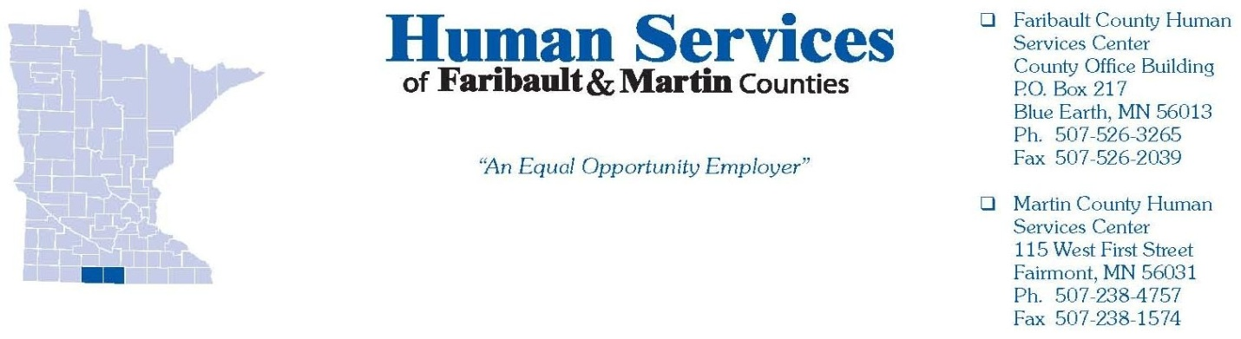
Adult Protection Prioritization Guidelines

Guiding Value
- Every action taken by Adult Protective Services must balance the duty to protect the safety of the vulnerable adult with the adult’s right to self-determination.

Principles
- Adults have the right to be safe.
- Adults retain all their civil and constitutional rights, i.e., the right to live their lives as they wish, manage their own finances, enter into contracts, marry, etc. unless a court adjudicates otherwise.
- Adults have the right to make decisions that do not conform with societal norms as long as these decisions do not harm others.
- Adults have the right to accept or refuse services.

Practice Guidelines
- Recognize that the best interests of the adult are the first concern of any intervention.
- Avoid imposing personal values on others.
- Seek informed consent from the adult before providing services.
- Respect the adult’s right to keep personal information confidential.
- Recognize individual differences such as cultural, historical and personal values.
- Honor the right of adults to receive information about their choices and options in a form or manner that they can understand.
- To the best of one’s ability, involve the adult as much as possible in developing the service plan.
- Focus on case planning that maximizes the adult’s independence and choice to the extent possible based on the adult’s capacity.
- Use the least restrictive services first whenever possible—community-based services rather than institutionally-based services.
- Use family and informal support systems first as long as this is in the best interest of the adult.
- Maintain clear and appropriate professional boundaries.
- In the absence of an adult’s expressed wishes, support casework actions that are in the adult’s best interest.
- Use substituted judgment in case planning when historical knowledge of the adult’s values is available.
- Do no harm. Inadequate or inappropriate intervention may be worse than no intervention.

Minnesota APS Mission: Adults who are vulnerable and those who support them receive the assistance they need to identify, prevent, report, stop, and minimize the risk for abuse, neglect, and exploitation through tribal, state, and county partnerships.

Adult Protective Services (APS) Response:
1. Clarify adult maltreatment reports by making calls to the initial reporter, internal agency contacts or others who may have knowledge of the situation.
2. When VA status/cognition is unknown and maltreatment exists, open for assessment to determine VA status.
3. Social Services will coordinate with law enforcement as needed when a crime is alleged.
4. Reports are prioritized based on the risk and/or harm to the VA.
5. Some reports opened for assessment may be an assessment with a determination of maltreatment while others maybe an assessment without a determination of maltreatment. The assessment type will depend on the type of maltreatment and the level of harm.
6. Resources and available services can be offered to all parties referred to APS.
7. The decision to accept a report for assessment, screen a report out for assessment, will be based on the following considerations:
• Are there previous calls of maltreatment or past investigations of the same allegation?
• Is there a role for APS?
• Does the VA have formal or informal support?
• Does the VA suffer from emotional or physical impairment?
• Does the VA have stable housing?
• Is cognitive status of VA known?
• What is the potential risk/harm if nothing is done?
• Is there risk of harm to VA if an assessment occurs?
• Can the VA protect self from harm?
• Can the VA engage in safety planning?
• Is the VA deceased?
• Is the report an indirect/hearsay report with insufficient detail?
• If a welfare check is appropriate to address a situation, coordination will be done with law enforcement or family/friends.

In the cases of scams and fraud, the county considers the following:
1. Is the person a VA under Minnesota State Statute MN Statute 626.5572 Subd. 21?
2. Is the person able to meet their basic needs?
3. Is there a protection need (i.e. rep payee, conservatorship)?
4. Do they have history of being scammed?
5. Would a reasonable person make these same decisions?
6. Is there an opportunity for return on their investment (i.e., gambling)?

In cases of unpaid facility bills, the county considers the following:
  - 1. Is the VA able to make their own financial decisions?
  - a. If they are managing their own finances and they have the capacity to do so, this is not considered maltreatment.
  - b. Facilities should be advised to send the individual’s debt to collections or put a lien on the individual’s property.
  - 2. Is there another person responsible for paying the bill?
  - 3. Is there a protection need or threat of eviction?
* Note: If an individual can make their own decisions, they have assets that can be liquidated, and they are choosing NOT to pay the facility; the county will not assess.

Options for discretionary override for assessment:
• Self-neglect can be resolved through case management or current services.
• Financial exploitation loss is unspecified or less than $200.
• VA is no longer in the State of Minnesota.
• VA is incarcerated at the time of the report.
• No benefit to VA from an adult protective services response.
• The VA is deceased.

* Note: override use is determined on a case-by-case basis.

Jurisdiction:
• Reports made to Minnesota Adult Abuse Reporting Center (MAARC) are forwarded to the county where the VA is located, not to the county where the alleged maltreatment occurred. If appropriate, the county receiving the report will make sure it goes to the county best equipped to address the concerns.
• We will work with tribal nations as required and appropriate.

