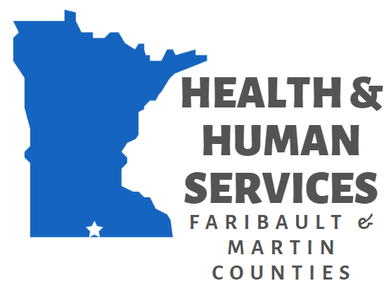
393 Family Childcare Variance Policy and Procedures
Status: ☐ Working Draft Approved
Effective Date: 2/11/2026
Responsible Department: Behavioral Health/Social Services
Next Review Due: 2029
Page 1 of ___

PURPOSE

Licensed family childcare providers have the right to request a variance of MN Rule 9502. The goal of Human Services of Faribault & Martin Counties’ variance policy is to meet the needs of parents and providers while keeping in mind that the requirements outlined in MN Rule are the minimum standard requirements for the safety and well-being of children served.

Effective January 1, 2021, Counties must use a uniform application form developed by the Commissioner for variance requests made by family childcare license holders. Counties must publish their policies and criteria for issuing variances on their public websites and also distribute those policies to all family childcare license holders annually.

Personnel Responsible: Licensing Social Worker and Social Services Manager.

POLICY

Human Services of Faribault & Martin Counties (HSFMC) is delegated authority, by the Commissioner of the Department of Children, Youth and Families, to issue variances for licensed family childcare that do not affect the health and safety of children in the licensed program. The license holder must request the variance PRIOR to the situation where it is necessary. The license holder must complete the variance PRIOR to the situation where it is necessary.

Variances will be reviewed by Licensing Social Worker and Social Services Supervisor monthly on or before the 15th of each month. Only variance requests submitted prior to the last day of the month prior will be reviewed. (Example, any variances submitted during the month of January will be reviewed by the 15th of February.)

The license holder must complete, in their entirety, all three approved Department of Children, Youth and Families variance forms:

- Variance Request: Family Child Care form (Variance Request: Family Child Care (DHS-7297))
- Family Child Care Weekly Attendance Schedule (Family Child Care Weekly Attendance Schedule (DHS-7297A))
- Variance Request Notice for Parents (Variance Request Notice for Parents (DHS-7297B)

Forms that are not completed in their entirety will be returned to the requestor for completion.

The request must include the following information:
- The sections of 9502 - MN Rules Chapter with which the applicant or provider cannot comply;
- The reasons why the applicant or provider needs to depart from the specified sections;
- The period of time for which the applicant or provider requests a variance; and
- The specific equivalent alternative measures which the applicant or provider will provide so the health, safety, and protection of children in provider’s care are ensured if the variance is granted; and
- Which specific child served by the program the variance will apply to.

When all completed documents are received by HSFMC, approval or denial will be made within 45 days. The Licensing Social Worker will review all submitted documents and confirm decision with Social Services Manager. A thorough review of the Licensing Rules will be completed in reference to the variance request. A review of possible options available to the license holder will be considered.

The provider will be informed in writing once by phone that the variance has been approved or denied. All notification regarding variance approval or denial will occur via email. All variances will begin on the date of approval and will not be back dated.

Written letter of approval for variance and any additional restrictions must be posted with current license within five business days of variance beginning.

It is up to providers to notify their food program of the start and end date of an approved variance. Licensing Social Worker must be included on this notification communication.

Other Rules and Conditions that apply to capacity or age group variances in Faribault and Martin Counties:
- Please do not request a variance more than two months in advance. We may ask you to wait if it is submitted too early. Your child count can change quickly.
- Variance requests for newborns (birth to six weeks old) can be requested, will be reviewed and DCYF will be consulted regarding possible additional license restrictions to approve request.
- No additional children can be added during the variance period without written authorization from HSFMC. Variances are child specific and limited to only the children listed on the variance form.
- In some cases, HSFMC may require that a second caregiver or helper be present in order for the variance to be approved.
- HSFMC will only grant one child specific variance per provider at a time.
- When a granted variance is not used, or partially used, the provider must notify the licensor to the extent the variance was used, since it may impact future requests.
- Additional terms may be required upon variance approval, and these will be outlined in the written approval, when applicable.

A variance will NOT be granted if any of the following apply:
- Provider is in their first year of licensure.
- Capacity would be over 14 children.
- During a pending investigation or negative action recommendation.
- During an existing negative licensing action.
- A correction order has been issued for overcapacity in the past 12 months.
- A correction order has been issued for lack of supervision in the past 12 months.
- For all variances, providers must be in compliance with all other licensing requirements not covered by the variance and failure to do so could result in immediate rescission of the variance.

******************************************************************************************************************

Variance must be approved (returned to provider and signed by the licensor and licensor’s supervisor) for provider to remain in compliance with childcare licensing statutes and to avoid a correction order.

Written letter of approval for variance and any additional restrictions must be posted with current license within five business days of variance beginning.

It is not guaranteed that provider will receive an approved variance.

Asking for a variance is asking Human Services of Faribault & Martin Counties to go against MN Rule and say that the situation is okay. HSFMC does not take this decision lightly. Variances are a risk of liability for HSFMC, providers, and the children served in programs operating with a variance. Variances create an opportunity to affect the health, safety, and well-being of multiple children.

HSFMC is under no obligation to grant any variances, and all variance decisions are up to the discretion of the Agency.

All variance decisions are final.

Revision History
REVISION DATE | EFFECTIVE DATE | APPROVED BY  £ Board Action  £ Administrative | REASON/COMMENTS
 | January 1, 2021 | Administrative | Original Policy
1/26/2026 |  | Administrative | Revisions per DCYF
2/11/2026 | 2/11/2026 | Board | Updated per DCYF

